Hello everyone,

In this reading, we will learn how to install Jupyter Notebook using Anaconda Distribution. And I will recommend this method to you if you are just starting with data science or python. It is a great tool which will ease your journey in data science project because of the following reasons:

* It is free and open-source
* It has more than 1500 Python/***R data science package***
* Anaconda simplifies package management and deployment
* It has tools to easily collect data from sources using machine learning and AI
* It creates an environment that is easily manageable for deploying any project
* Anaconda is the industry standard for developing, testing and training on a single machine
* It has good community support- you can ask your questions there.

What you get

* Download more than 1500 Python/R data science packages
* Manage libraries, dependencies, and environments with conda
* Build and train ML and deep learning models with scikit-learn, TensorFlow and Theano
* Use Dask, NumPy, Pandas and Numba to analyze data scalably and fast
* Perform visualization with Matplotlib, Bokeh, Datashader, and Holoviews

Install Python and Jupyter using the Anaconda Distribution, which includes Python, the Jupyter Notebook, and other commonly used packages for scientific computing and data science.

Anaconda is an open-source software that contains Jupyter, spyder, etc that are used for large data processing, data analytics, heavy scientific computing. Anaconda works for R and python programming language. Spyder(sub-application of Anaconda) is used for python. Opencv for python will work in spyder. Package versions are managed by the package management system called conda.

To begin working with Anaconda, one must get it installed first. Follow the below instructions to Download and install Anaconda on your system:

**Download and install Anaconda:**

Head over to [anaconda.com](https://www.anaconda.com/distribution/#windows) and install the latest version of Anaconda. Make sure to download the “Python 3.7 Version” for the appropriate architecture.  
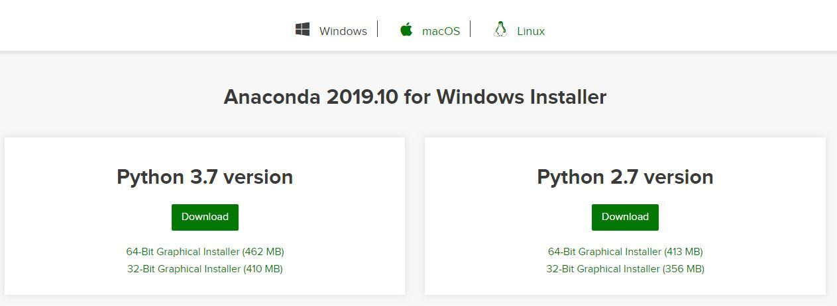

**Begin with the installation process:**

* **Getting Started:**  
  
* **Getting through the License Agreement:**  
  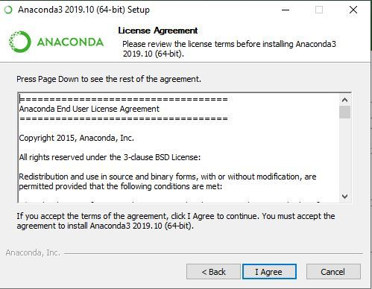

**Select Installation Type:** Select **Just Me** if you want the software to be used by a single User

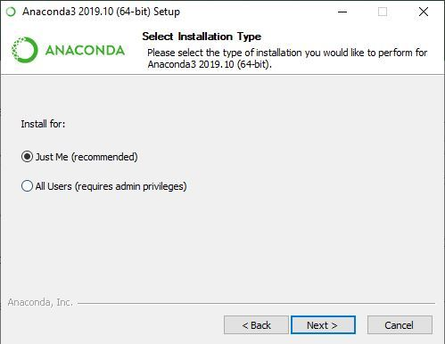

* **Advanced Installation Option:**  
  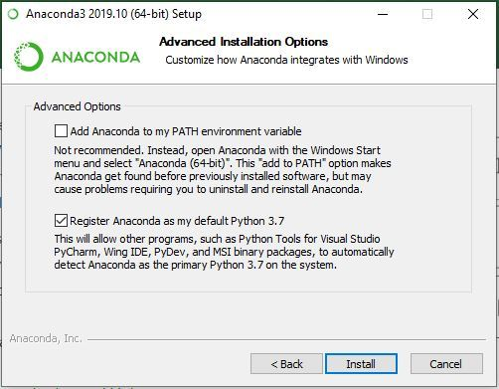
* **Getting through the Installation Process:**  
  
* **Recommendation to Install Pycharm:**  
  
* **Finishing up the Installation:**  
  

**Working with Anaconda:**

Once the installation process is done, Anaconda can be used to perform multiple operations. To begin using Anaconda, search for Anaconda Navigator from the Start Menu in Windows

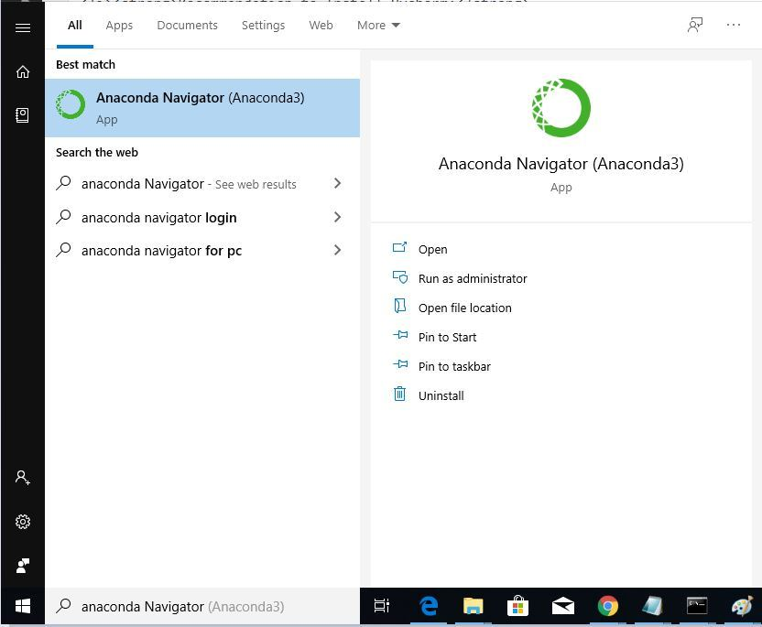

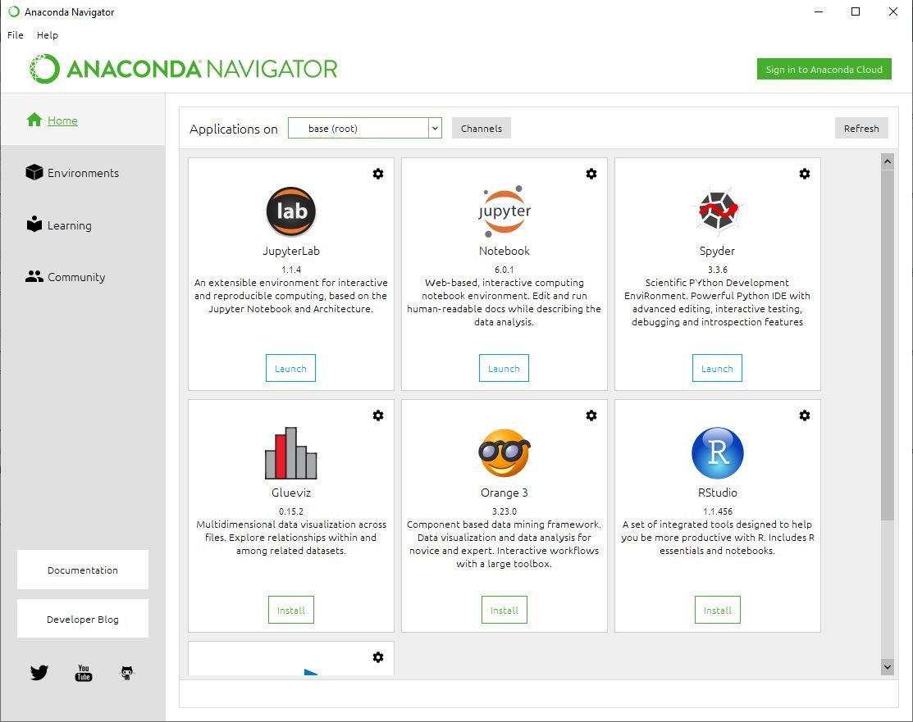

To install Jupyter using Anaconda, just go through the following instructions:

* **Launch Anaconda Navigator:**

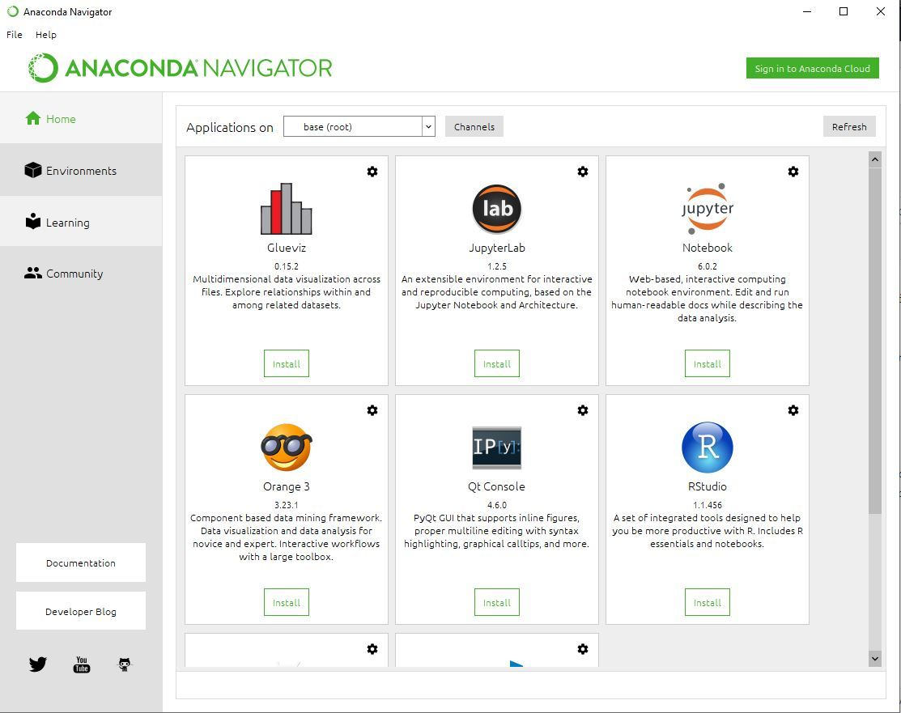

* **Click on the Install Jupyter Notebook Button:**
* 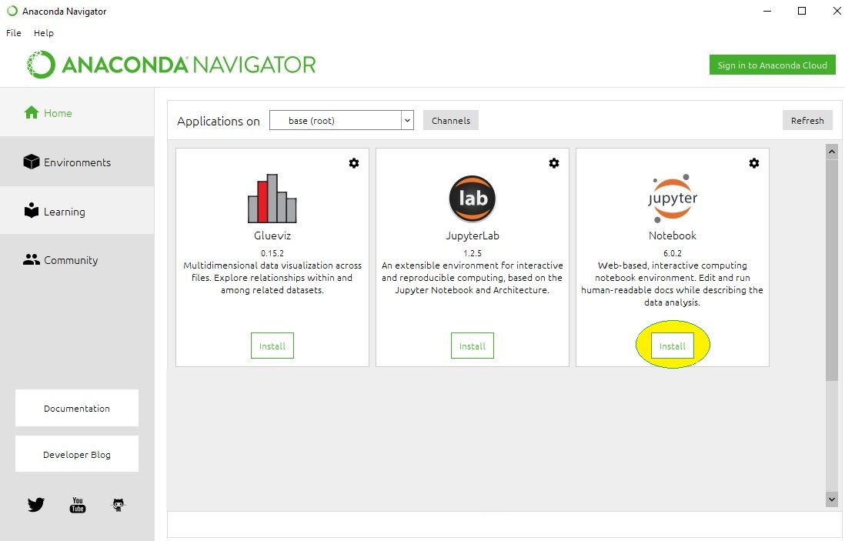
* **Beginning the Installation: Then it will start the installation and will import and download all the necessary packages. It may take some time depending on your internet connection speed.**
* **Finished Installation:**

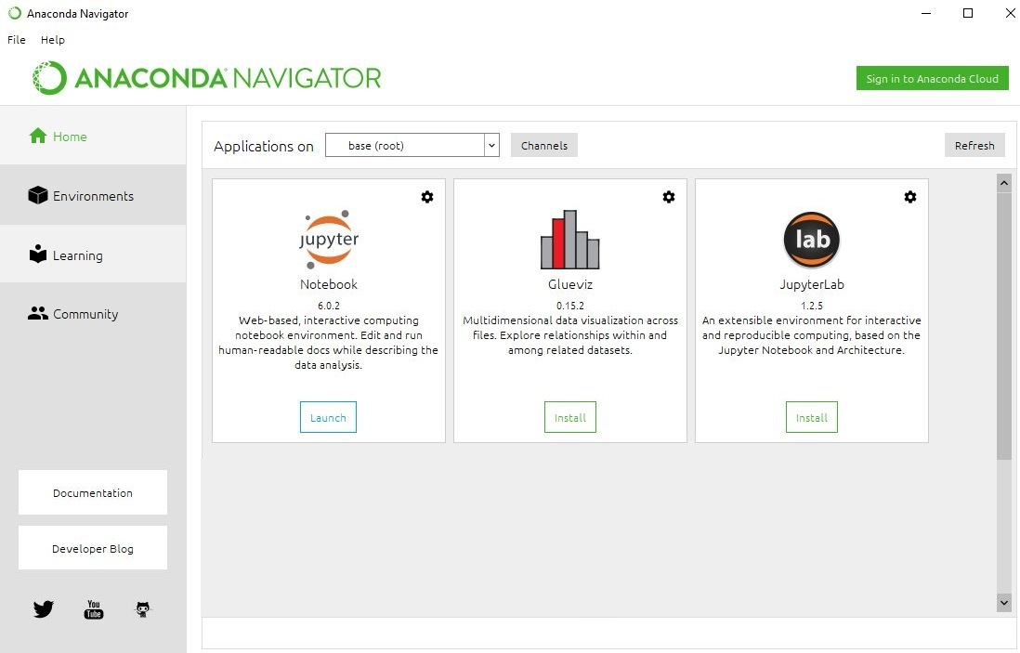

**Launching Jupyter: To launch the jupyter notebook click on the launch button which is below jupyter notebook, and the default page of the notebook will get open in your default web browser.**

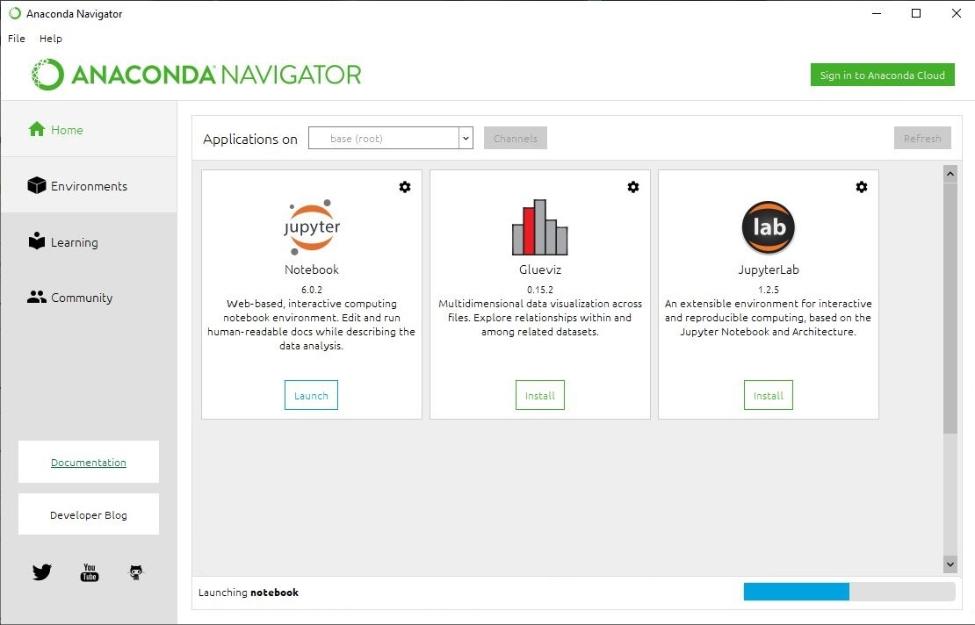

**What Companies are Using Anaconda?**

Anaconda is trusted by these leading companies around the world:

* BMW
* Cisco
* Citi Bank
* HSBC
* GlaxoSmithKline
* GE Power
* Samsung
* Zurich
* Brookhaven
* City of Boston
* Columbia University
* CloudQuant
* IQT
* Lloyds Banking Group
* Otto Group
* Machinalis
* Marshall Wace
* Mayo Clinic
* Micron
* Molex
* National Grid
* PIMCO
* US Army Corps of Engineers
* West Health
* US Securities and Exchange Commission
* SunTrust
* Banco Pichincha
* ComEd
* RENNER
* elo
* But even other than these, Anaconda has more than 15 million users worldwide.